**VAS** Patient Name: _____________________________________________________ Date: _____________________

How long have you had your symptoms? _____ days _____ weeks _____ months _____ years

On the diagram below, please indicate where, and what type of symptoms that you are experiencing, right now. Write the appropriate abbreviations (see the key below) over the area of the body where those symptoms are occurring.

__________________________________________________________________________________________________

A = Ache B = Burning N = Numbness P = Pins and Needles S = Stabbing O = Other _______

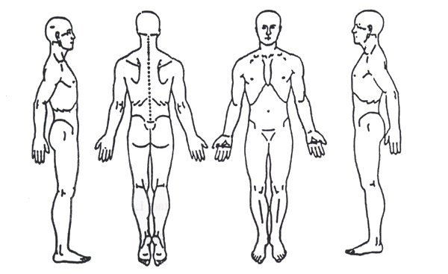

Instructions: Please circle the number that corresponds to the pain level that you are experiencing.

Note: If you have more than one complaint, please indicate your pain levels for each complaint. Please indicate your pain level for (1) your pain at its worst, (2) your pain at its best, (3) your pain right now and (4) your average pain level.

Example: no pain 0 1 2 3 4 5 6 7 8 9 10 worst possible

1. My pain when it is at its worst is: no pain 0 1 2 3 4 5 6 7 8 9 10 worst possible
2. My pain at its best is: no pain 0 1 2 3 4 5 6 7 8 9 10 worst possible
3. My pain right now is: no pain 0 1 2 3 4 5 6 7 8 9 10 worst possible
4. My average pain level is: no pain 0 1 2 3 4 5 6 7 8 9 10 worst possible

Patient/Other Signature: __________________________________________________________________________

Relationship to Patient: ___________________________________________________________________________

**VAS** Patient Name: _____________________________________________________ Date: _____________________

How long have you had your symptoms? _____ days _____ weeks _____ months _____ years

On the diagram below, please indicate where, and what type of symptoms that you are experiencing, right now. Write the appropriate abbreviations (see the key below) over the area of the body where those symptoms are occurring.

__________________________________________________________________________________________________

A = Ache B = Burning N = Numbness P = Pins and Needles S = Stabbing O = Other _______



Instructions: Please circle the number that corresponds to the pain level that you are experiencing.

Note: If you have more than one complaint, please indicate your pain levels for each complaint. Please indicate your pain level for (1) your pain at its worst, (2) your pain at its best, (3) your pain right now and (4) your average pain level.

Example: no pain 0 1 2 3 4 5 6 7 8 9 10 worst possible

1. My pain when it is at its worst is: no pain 0 1 2 3 4 5 6 7 8 9 10 worst possible
2. My pain at its best is: no pain 0 1 2 3 4 5 6 7 8 9 10 worst possible
3. My pain right now is: no pain 0 1 2 3 4 5 6 7 8 9 10 worst possible
4. My average pain level is: no pain 0 1 2 3 4 5 6 7 8 9 10 worst possible

Patient/Other Signature: __________________________________________________________________________

Relationship to Patient: ___________________________________________________________________________